📘 Assignment: Phases of Penetration Testing

🔹 Task 1: Install Nmap and Scan Your Local Network
Objective
Install Nmap and perform a basic host discovery scan on your local network.
Installation
Download Nmap from:
Nmap
Official website:
Nmap Official Download

Command
nmap -sn 192.168.1.0/24
(Replace 192.168.1.0 with your own subnet if different.)

Save the Output
nmap -sn 192.168.1.0/24 > scan_results.txt
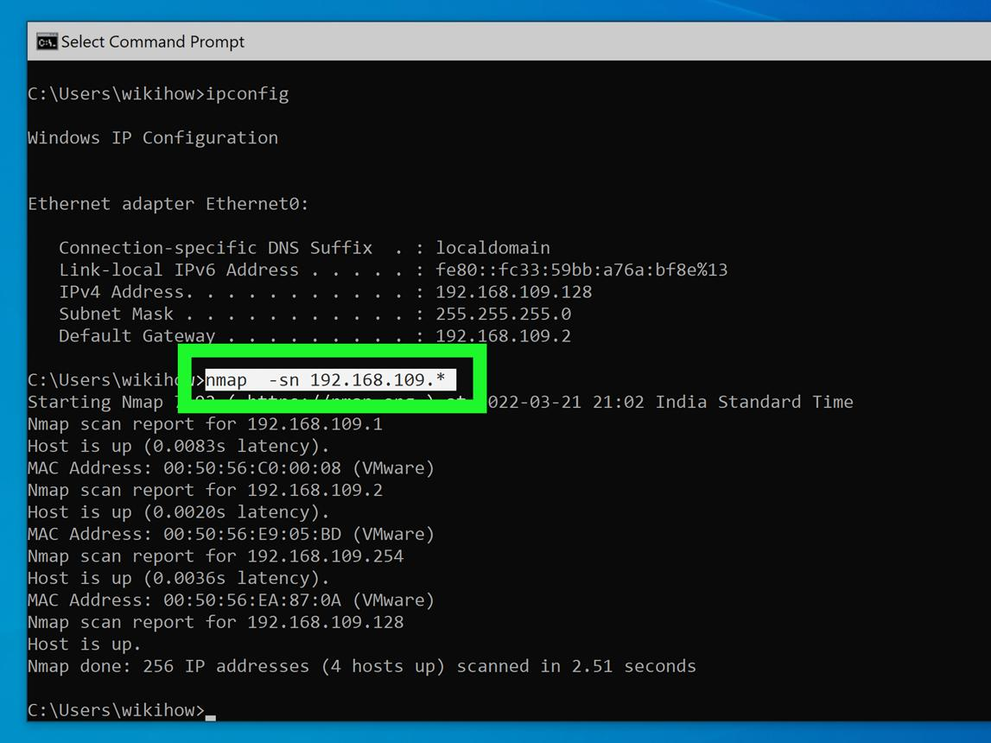
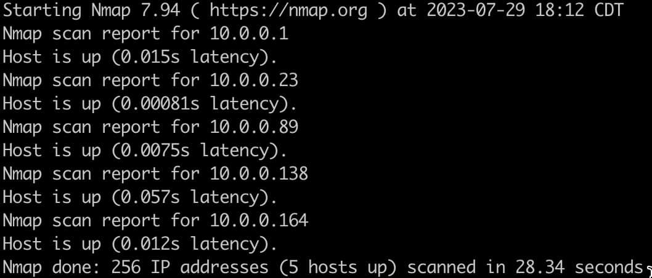
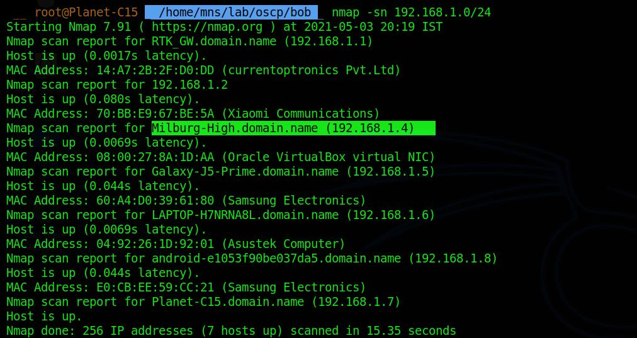
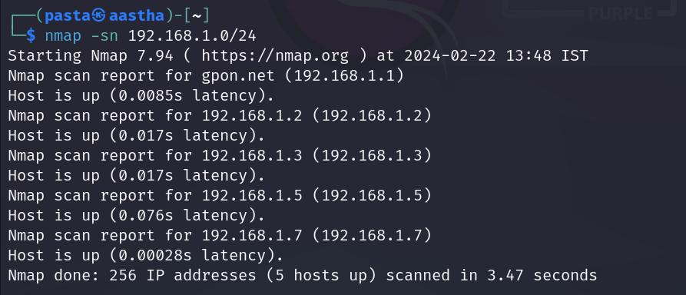

🔹 Task 2: Reconnaissance Phase
Selected Application
Instagram
Answer
During the reconnaissance phase, a penetration tester gathers publicly available information about Instagram without attempting to exploit the system. This may include identifying the application's domains and subdomains, IP ranges, public APIs, technology stack, server locations, login pages, exposed services, and security headers. The tester may also review publicly available documentation, DNS records, SSL certificates, and information disclosed through search engines. The purpose of reconnaissance is to understand the target environment and identify potential areas that require further security assessment.

🔹 Task 3: Perform a Port Scan
Command
nmap -sS scanme.nmap.org
Note: scanme.nmap.org is an official host provided by the Nmap project for testing purposes.
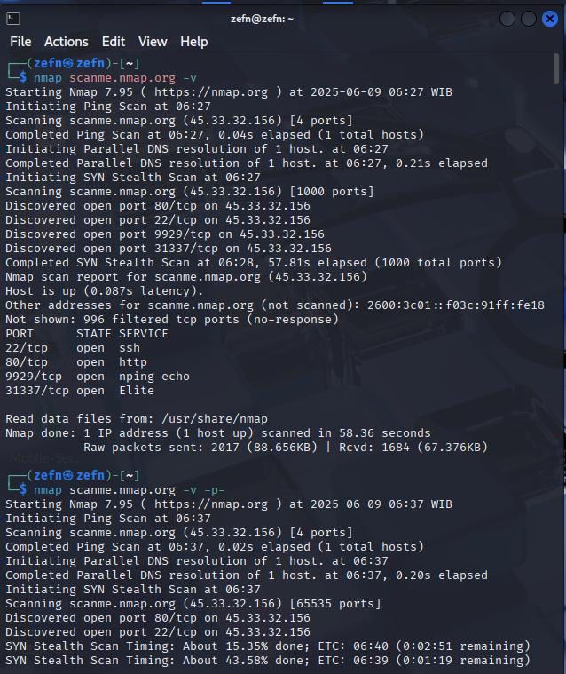
🔹 Task 4: Penetration Testing Report
Client Report
Client Name: Test Network
Assessment Type: Basic Network Scan
Tool Used: Nmap 7.97

Summary
A network discovery and port scanning assessment was performed using Nmap. Three active hosts were identified during the host discovery scan. A SYN scan of the approved test server (scanme.nmap.org) identified open ports including 22 (SSH) and 80 (HTTP). These services appear reachable from the internet and should be regularly monitored, patched, and configured securely. No exploitation activities were performed as part of this assessment. Overall, the scan demonstrates that only necessary services should remain exposed to reduce the attack surface.

Findings
Finding | Result
Hosts Discovered | 3
Open Ports | 22 (SSH), 80 (HTTP)
Scan Type | SYN Scan (-sS)
Tool Used | Nmap

Recommendations
- Keep operating systems updated.
- Disable unused ports and services.
- Restrict SSH access using firewall rules.
- Perform regular vulnerability assessments.
- Monitor exposed services for unusual activity.

